

Umbria 2020.1.1
Azure Setup and Configuration
Reference Guide

Table of Contents
Azure Setup 4
Setting Up Azure Virtual Machines for Umbria Web or Agent Servers 4
To setup Azure SQL server: 8

Azure Setup

Setting Up Azure Virtual Machines for Umbria Web or Agent Servers
- Search “Virtual Machines” in the main search bar of portal.azure.com, or use the shortcut if it’s already shown for you. 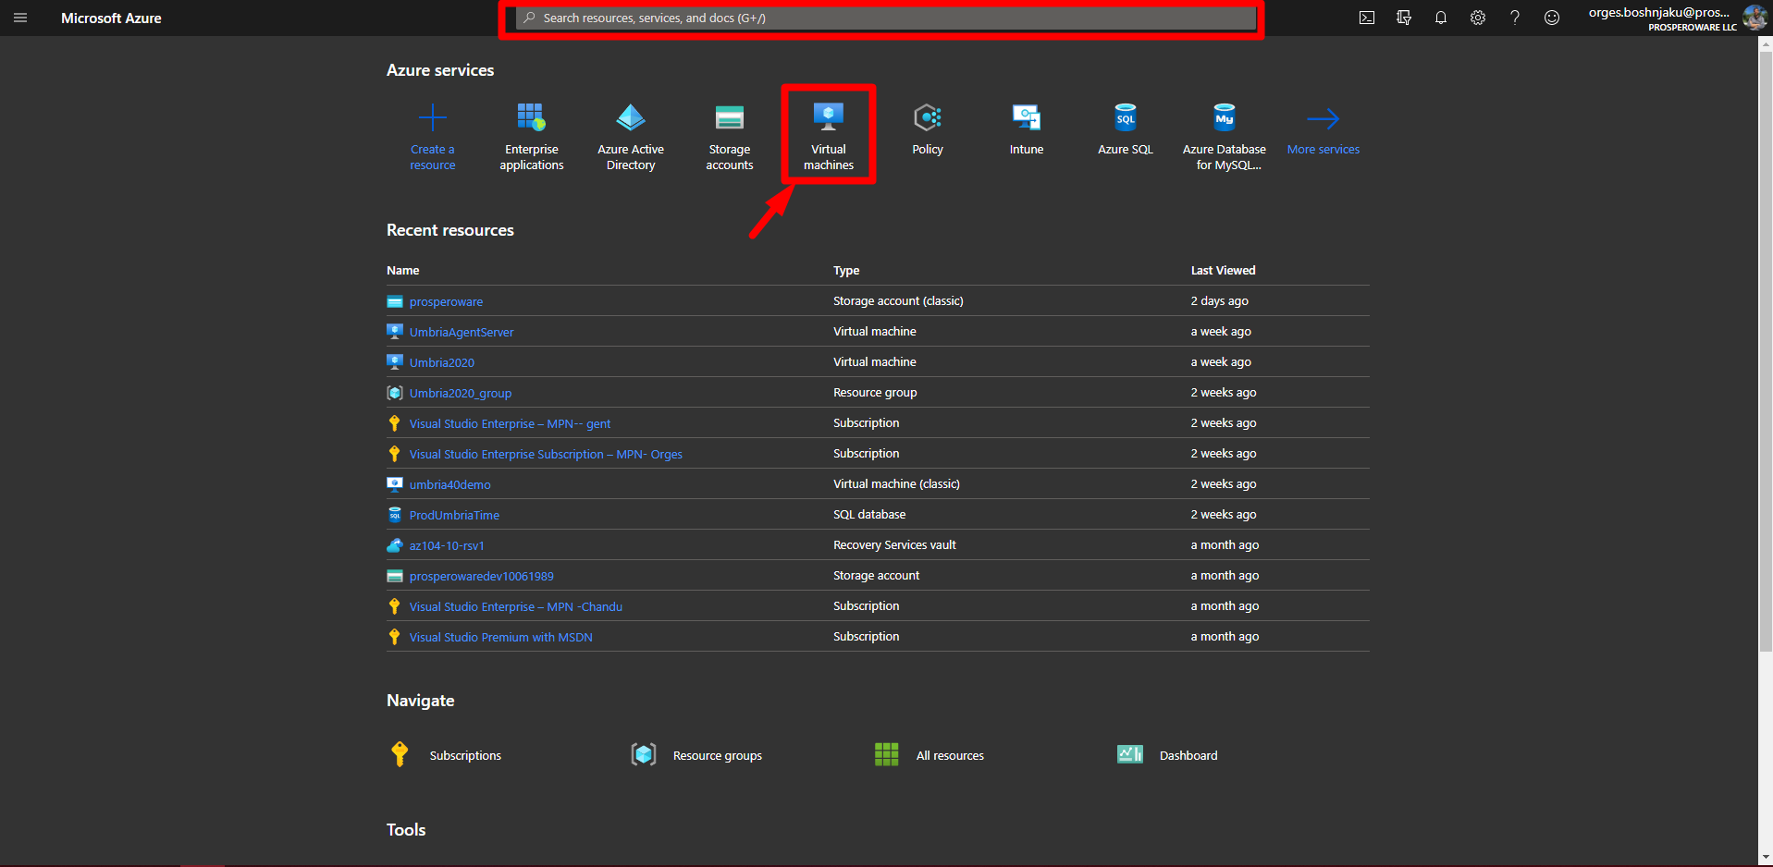
- When on the “Virtual Machine” tab, under “Add”, go to the “+ Virtual Machine” option.
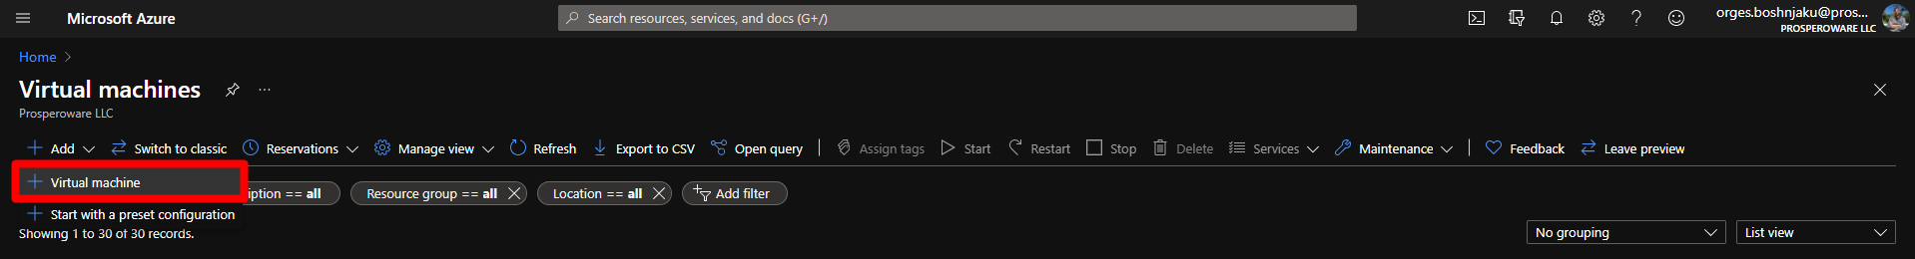
- Fill in the information on the Virtual Machine you want to create, based on the infrastructure you will need for your Umbria application. (the default values will work for the most part)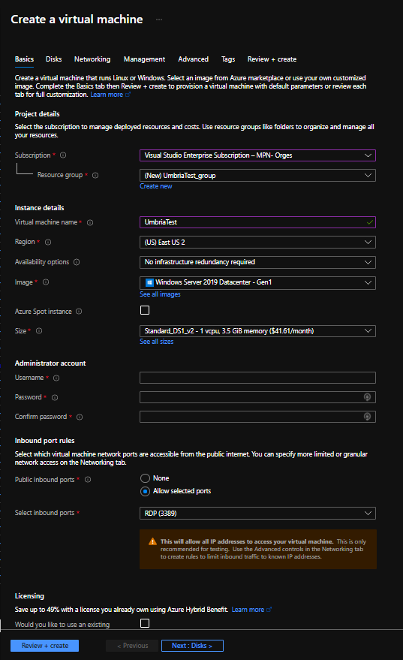
- Select the “Image” for the Operation System you want your Umbria to be hosted on.

- If you want to host your Umbria on a public website, make sure to allow under “Select inbound ports” the HTTPS (443), or any other ports in case of need.
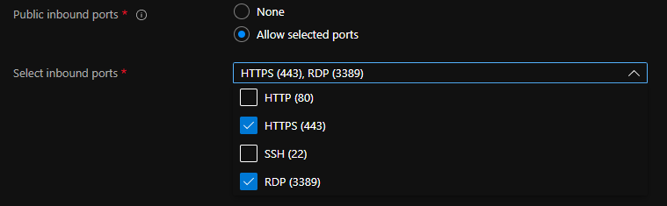
- After click “Next: Disks”, choose the disks according to your plans.
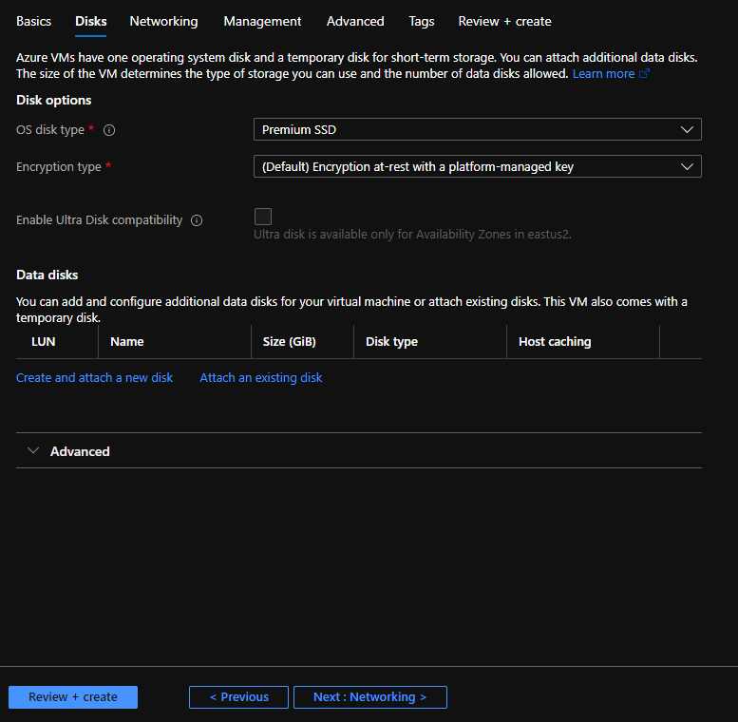

- Next, a new Virtual Network will be created, default options will work fine. 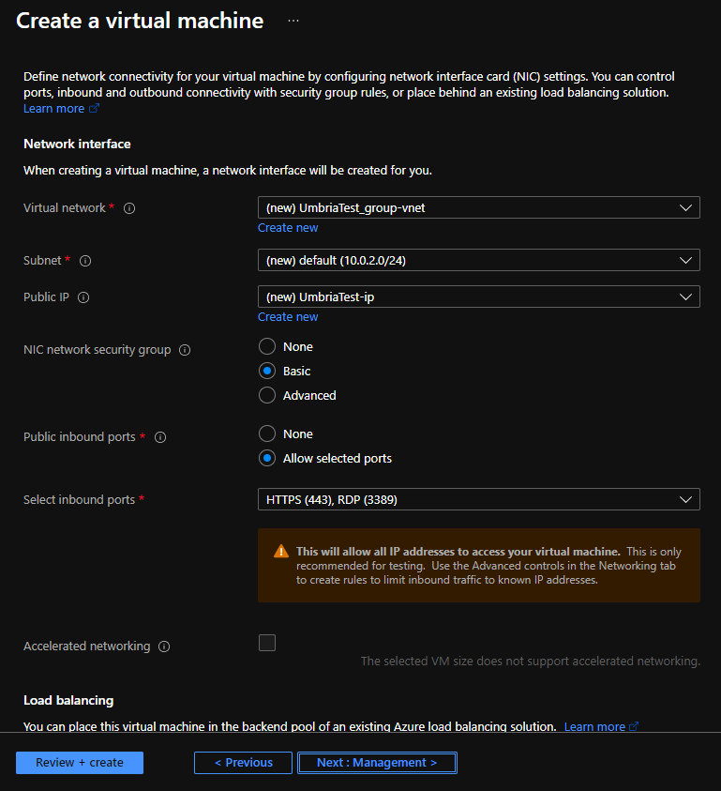
- Next, make any management changes you need according to your organization's requirements. You may as well change the Gen of the Virtual Machine under the “Advanced” tab.
- After, Clock on “Review+Create” and “Create”.
- Once your machine is created, go to “Virtual Machines” again, select the Virtual Machine that was just created, after, you can simply download the RDP file under “Connect”, and double click to connect to it, with the credentials as preset under “Basic” tab. (point number 3) 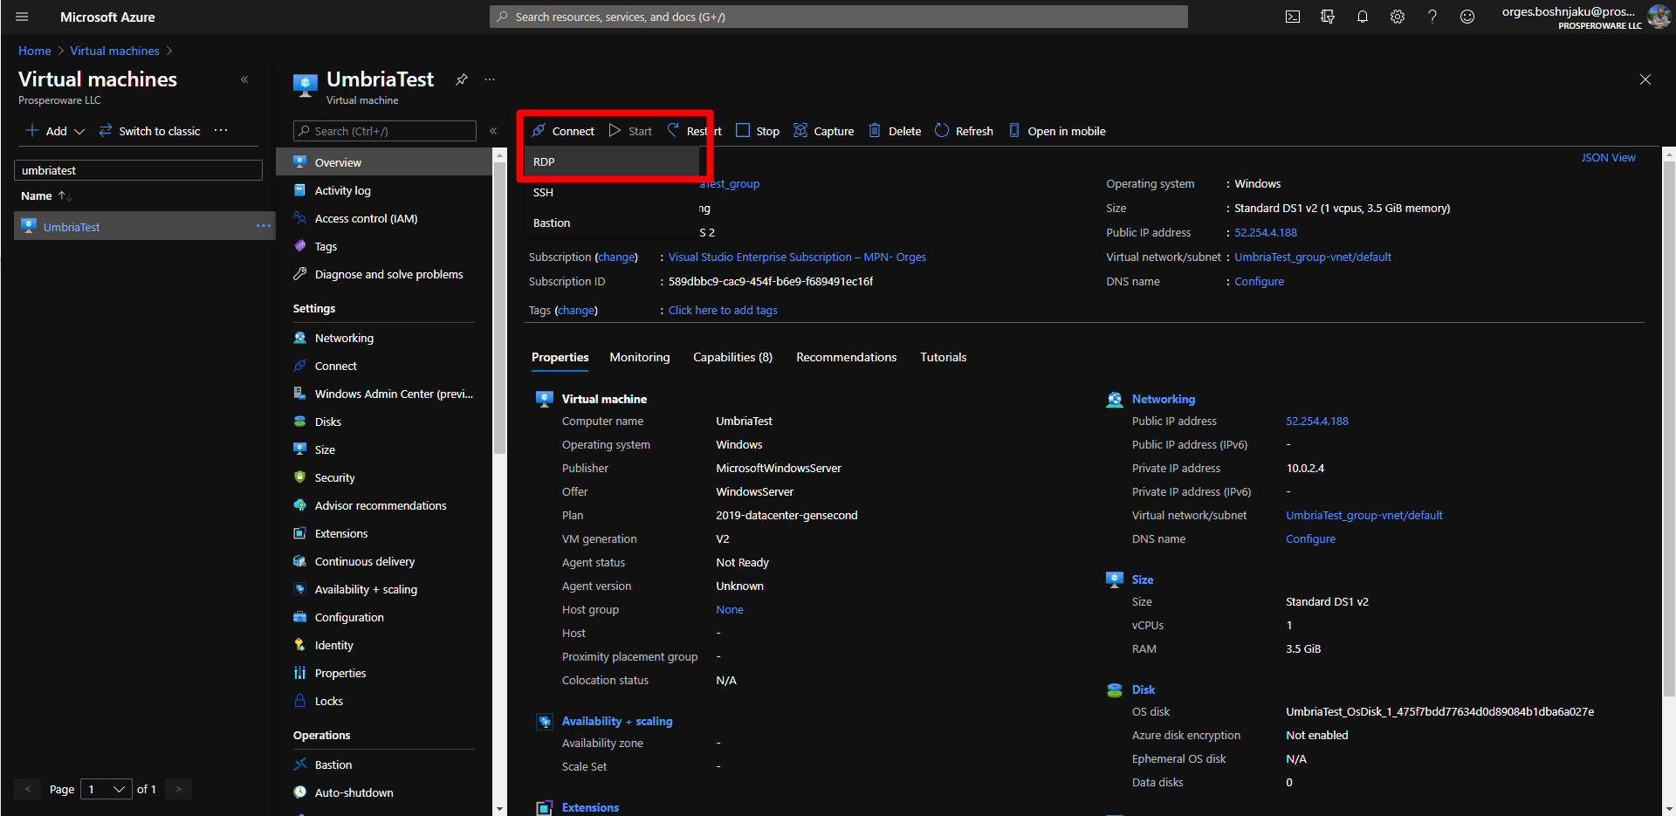
- Install Umbria on the virtual machine(s) as a normal install. See Umbria documentation here. Repeat steps 1-10 for each Virtual machine required for Umbria (3 total servers, one web server, one agent server, one SQL server). Nothing is different if SQL is on a VM as described here.

To setup Azure SQL server:
If you choose not to use a VM for SQL as above and use Azure SQL instead, use these steps to configure that. Once the steps are completed, you can install Umbria as regularly providing the Azure SQL name and port for the server.
- Navigate to the Azure SQL
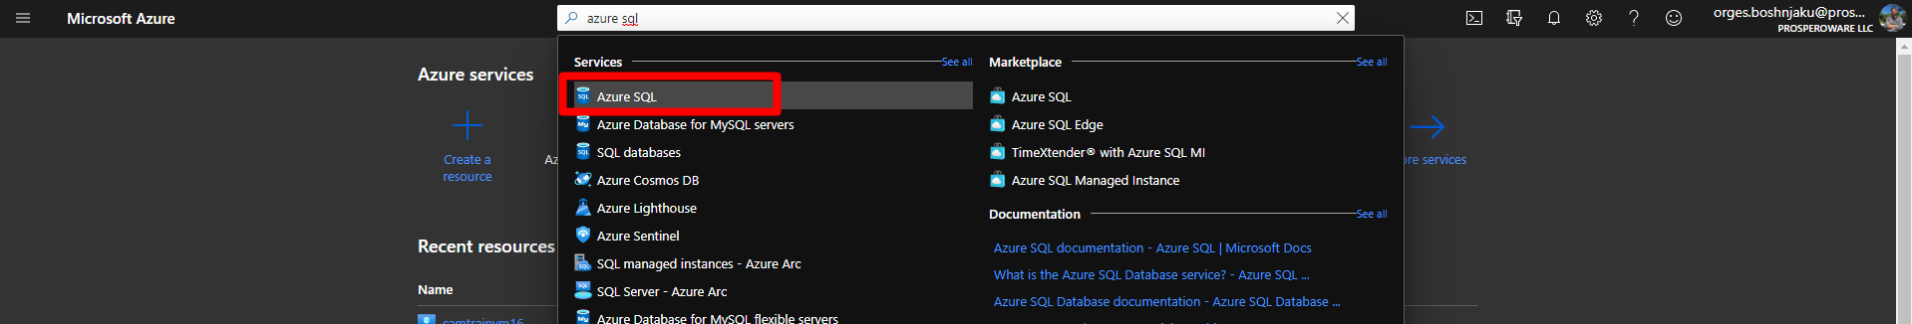

- Click on “New” and “Create” under “SQL Databases”
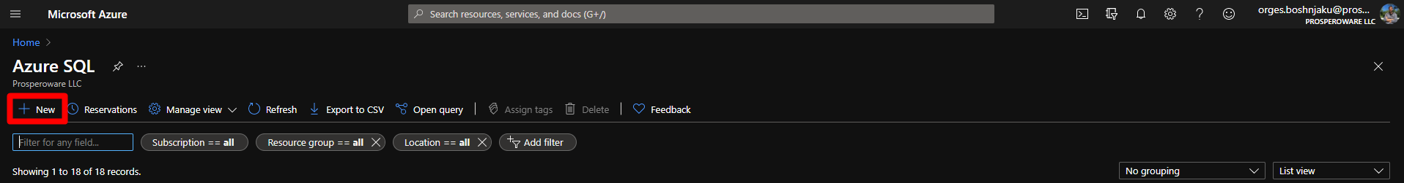
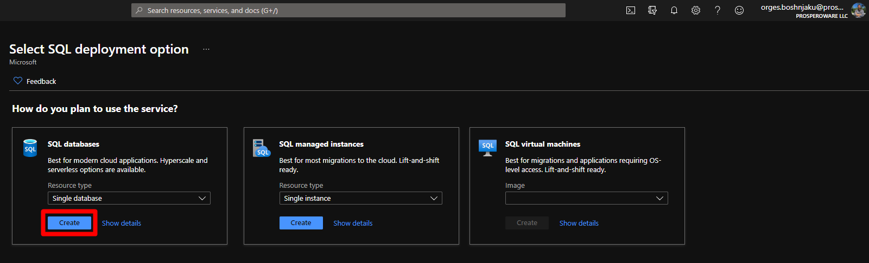

- After selecting a subscription, Fill in the “Database name”, under “Serve” click “Create new” and fill the “New Server” fields as desired.
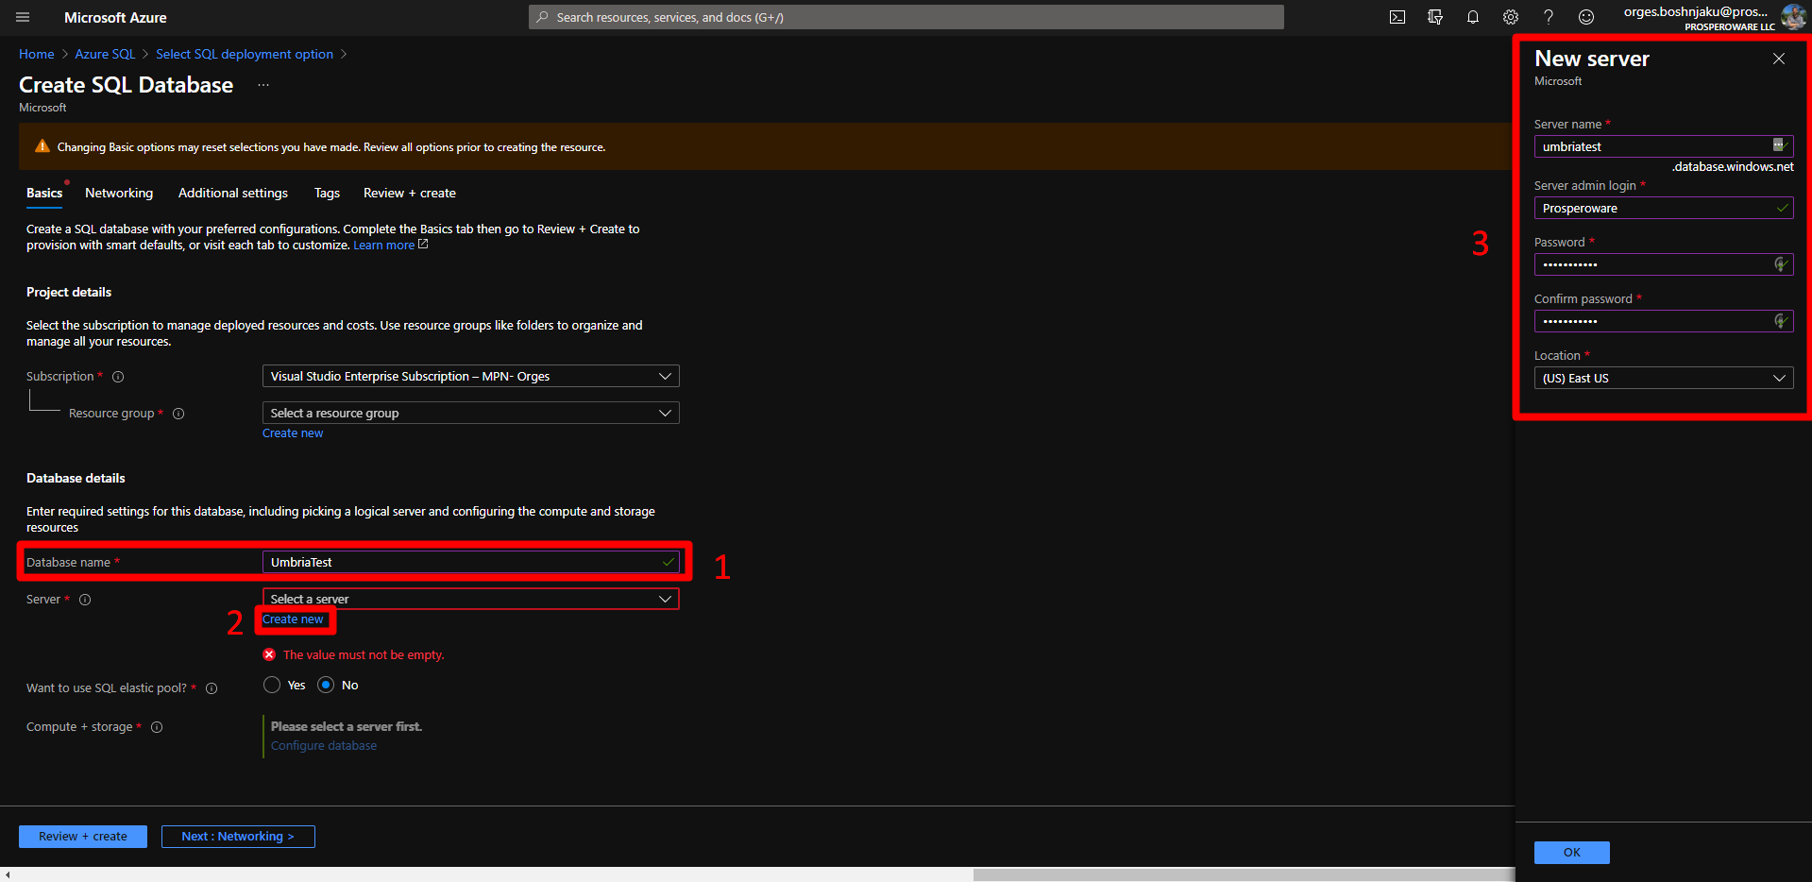
- Select the “Compute + storage” as requested for your planned infrastructure.
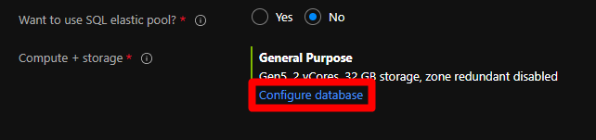

- After, click “Networking” and choose the “Connectivity Method” based on the access you want to have in the database. If you plan to connect through any SQL Server via SSMS, you will need to add either public or private endpoint, depending on the security you require in that database. You will also need to “Allow Azure services and resources to access this server” if the Virtual Machine is hosted by the Azure Virtual Machines.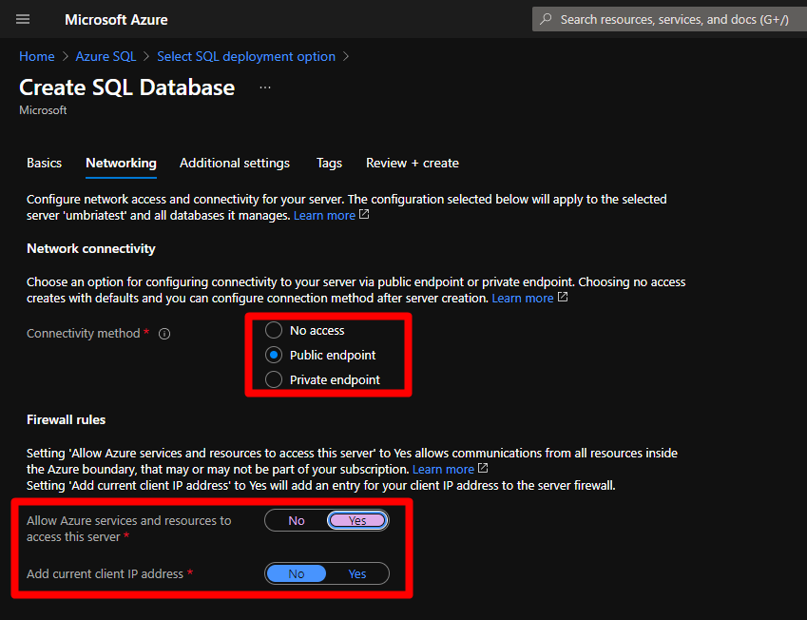

- In the next step, all the other settings under “Additional settings” are optional and different for each environment.

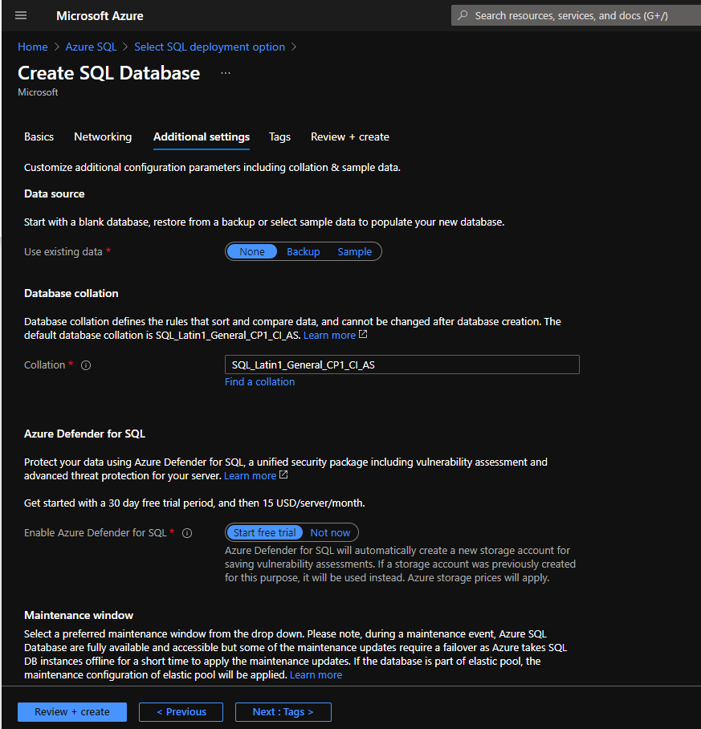

- Then under “Review + Create” click on “Create”
- After the Database is created, go to “Azure SQL” once again and find your created database. 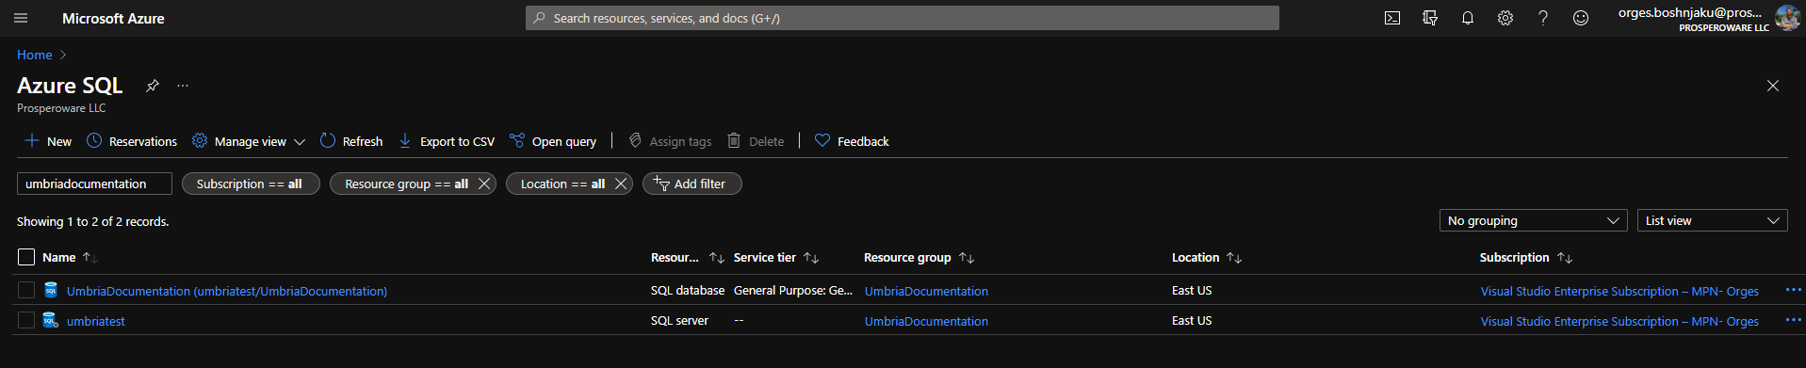

- To access it from the SSMS as planned before, you need to allow the IPs (or a range of IPs) on this database through the “Firewalls and Virtual Networks” tab on the left. 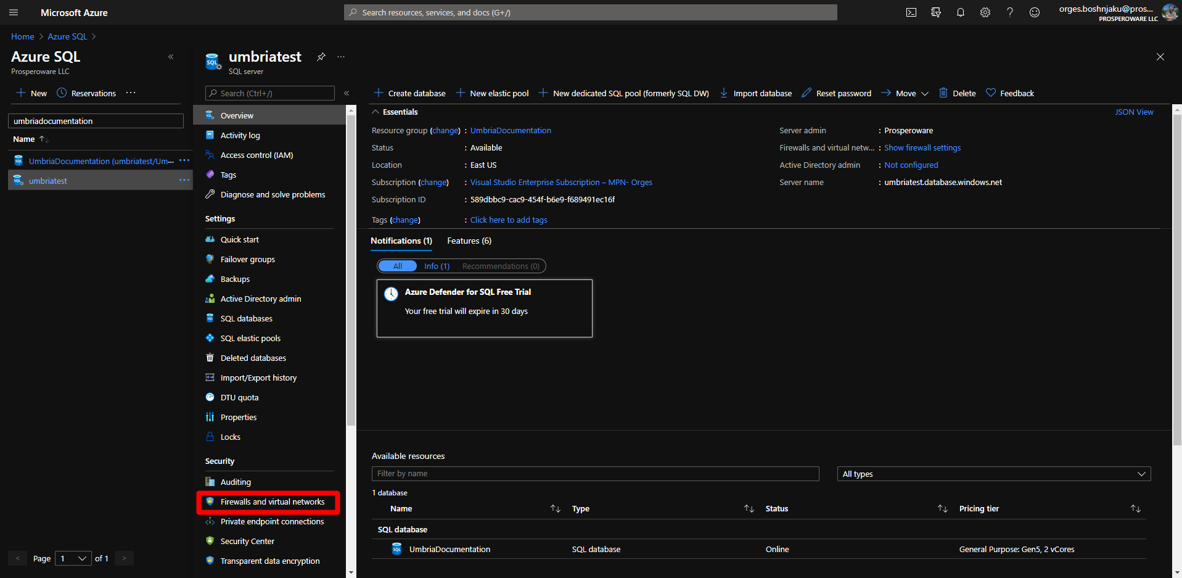

- Here’s an example of allowing connection via my personal IP 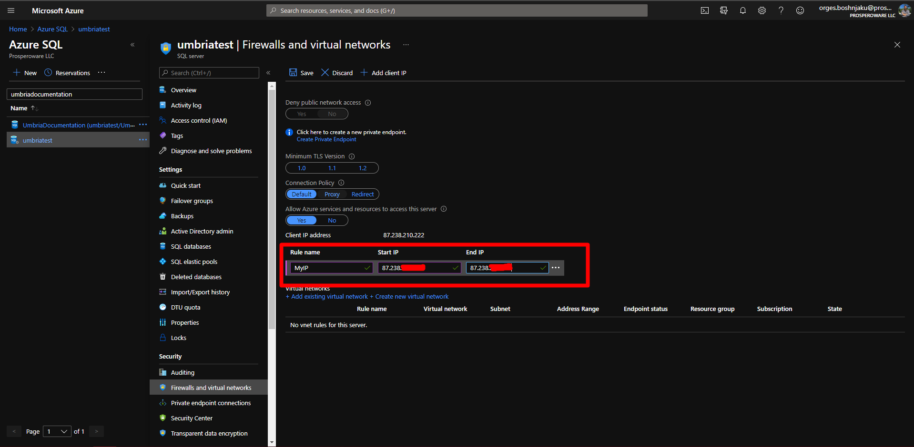

- After allowing the IP, go to your desired machine with an SSMS installed (SQL Server) and click on connect. Find the “Server name” under the “Overview” tab of the database you have created and the credentials as preset.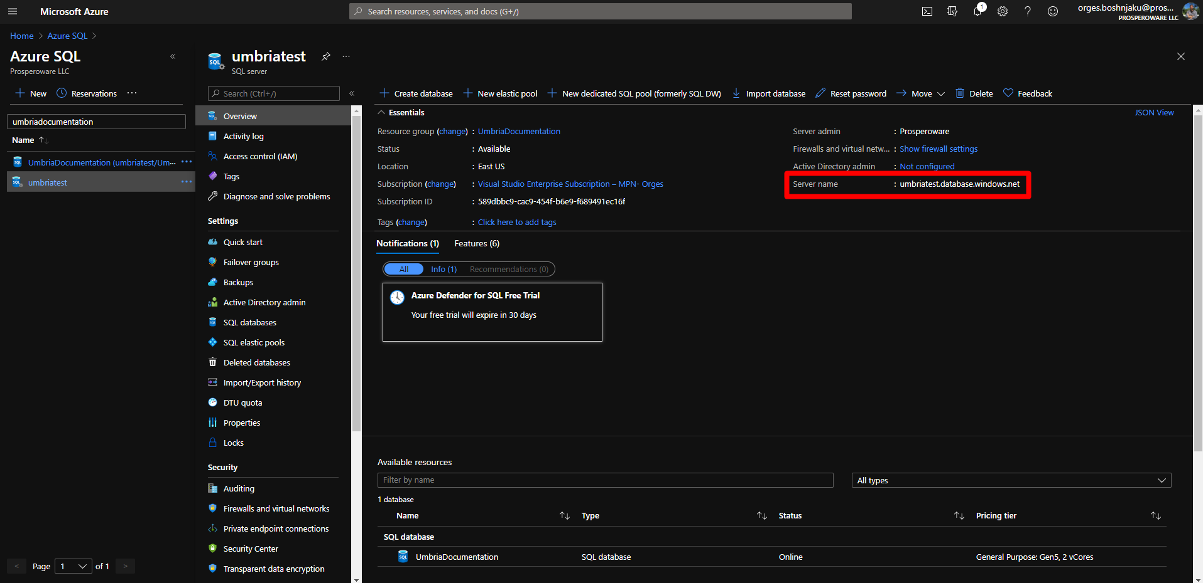

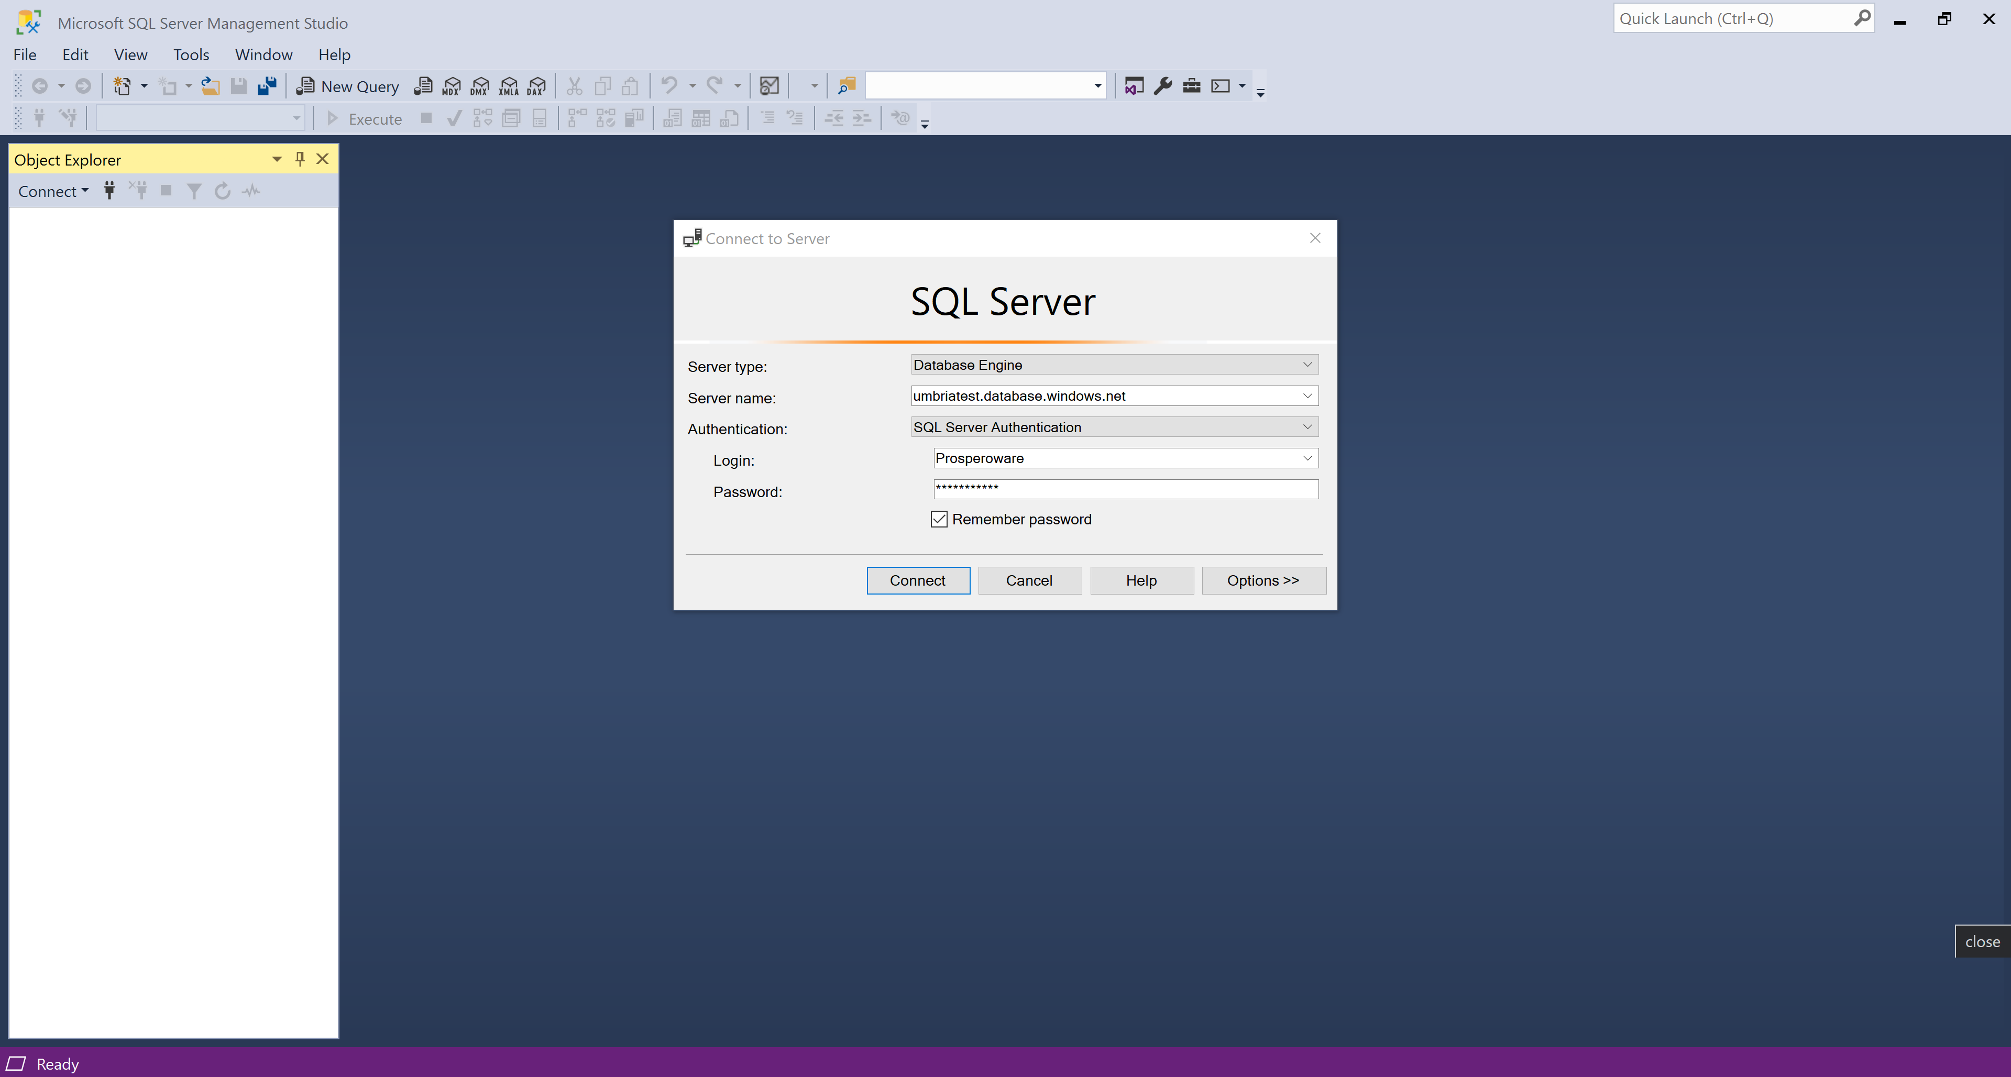

- Once connected, you can find the listed databases. 